Project Documentation
Title: Deployment of a Website on Linux with AWS RDS Integration

Abstract:
This project aims to develop a web-based Electronics Parts Sales and Inventory System that manages electronic product data, customer records, transactions, and inventory levels. The system enables seamless order tracking, stock monitoring, and user authentication, ensuring efficient sales and inventory operations. Hosted on AWS (EC2 + RDS), it integrates a PHP frontend with a MySQL backend to support real-time data access and scalability.

Introduction:
In the current digital era, managing inventory and sales using manual methods or spreadsheets leads to data inconsistency, human error, and inefficiency. A centralized web-based system provides automation, improves accuracy, and enhances user accessibility. The Electronics Parts Sales and Inventory System is designed to serve small-to-medium electronic parts businesses by offering a responsive and easy-to-use interface for managing employees, customers, products, and sales.

Existing System:
The existing manual or semi-digital systems suffer from:
- Manual entry errors and duplication
- Delayed stock updates
- No real-time sales data
- Lack of multi-user access and audit trails
- No cloud-based accessibility
- Difficult to scale and integrate with modern applications

Proposed System:
The proposed system overcomes the limitations of the existing one by:
- Automating all key operations (sales, customer, inventory, and employee management)
- Storing data in AWS RDS MySQL for cloud-based accessibility
- Using a PHP-based UI hosted on an EC2 instance
- Supporting secure login for admins and users
- Providing detailed reports and real-time stock levels
- Enabling CRUD operations (Create, Read, Update, Delete) via a responsive interface
Key Modules:
- User Authentication (Admin, Staff)
- Customer Management
- Product & Category Management
- Inventory Tracking
- Order & Transaction History
- Reporting Dashboard

Conclusion:
The Electronics Parts Sales and Inventory System successfully streamlines the sales and inventory processes for electronic businesses. By migrating to a cloud-based architecture, it ensures data reliability, accessibility, and performance. It reduces manual efforts, enhances accuracy, and provides clear visibility into operations.

Future Enhancements:
~ Add barcode/QR code scanning for inventory
~ Implement role-based access control
~ Introduce RESTful APIs for mobile app integration
~ Integrate with payment gateways and e-invoicing
~ Add email/SMS notifications for stock alerts and order status
~ Include advanced data analytics using dashboards

System design:

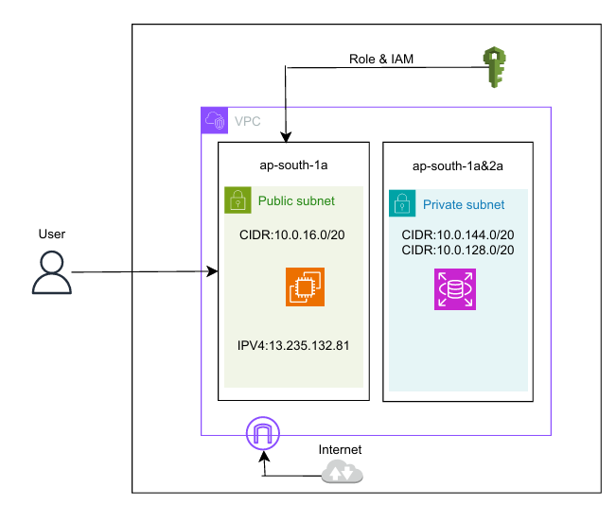

Appendices:
Hosting our Contact data website and entering the data.
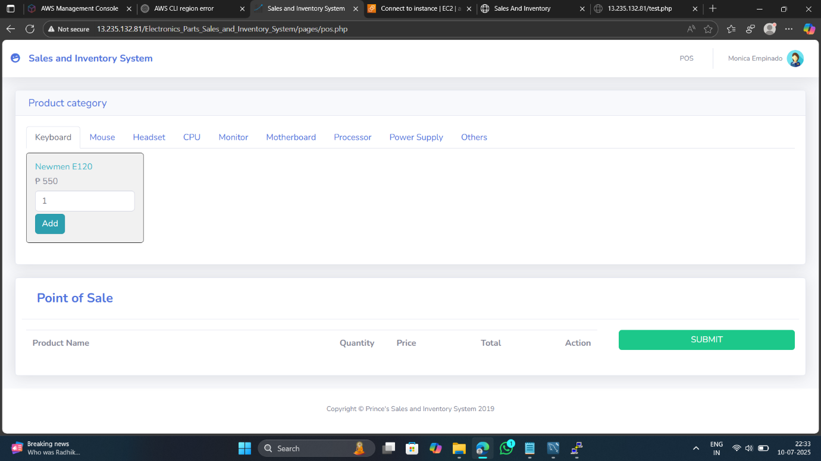
The Data are entered Successfully
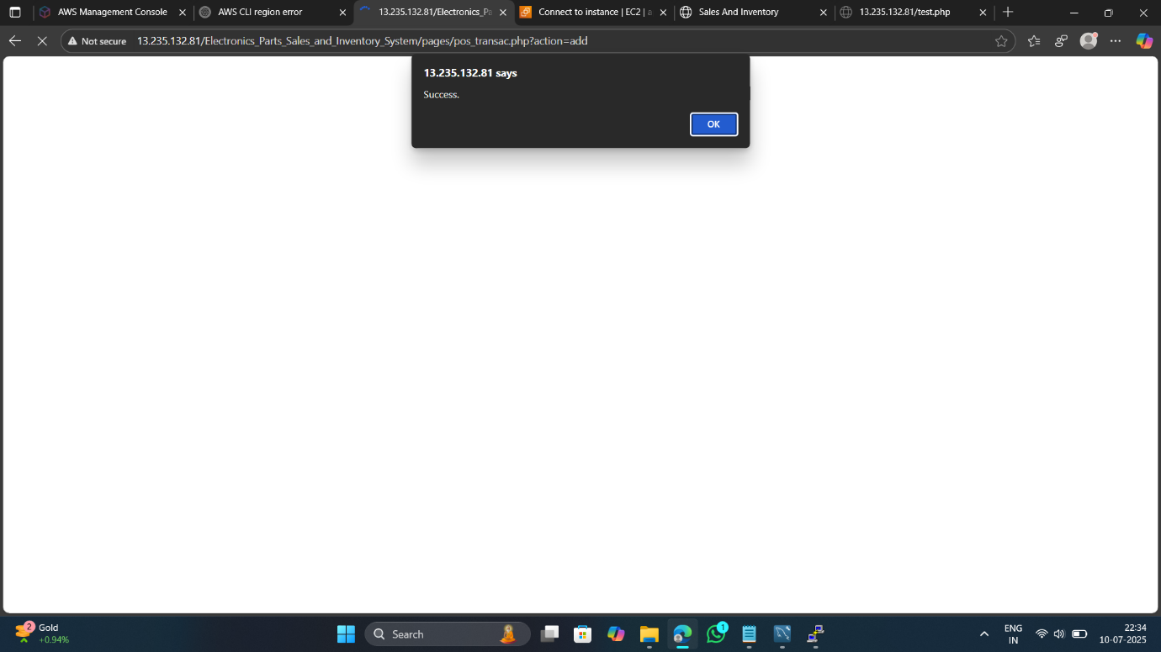

Data are Stored in our Database
